ORDINANCE 2024-1
AN ORDINANCE TO CLOSE, VACATE AND ABANDON THE RIGHT OF WAY OF REDWING AVENUE.
WHEREAS, there is shown on the final plan of Pendleton and Blair's Subdivision of Lynwood Park dated June 1913 and ofrecord in Book 421, Page 45, Register's Office of Davidson County, Tennessee ("RODC"), a proposed street.

WHEREAS, a revision of the plan of Lynwood Park, dated May 8, 1974, and recorded at Book 4675, Page 109 (RODC), identifies the proposed street as "Redwing Avenue" (hereinafter sometimes called "the Street"); and

WHEREAS, the Street is also shown on the recorded plan of the Resubdivision of Lots 21, 22, 23, and the Southerly 50 Feet of Lot 24 as Shown on the Unrecorded Plat of Honeywood Subdivision, of record in Plat Book 5200, Page 324 (RODC) and on the Recorded Plan of Deux Properties, of record in Plat Book 6900, Page 227 (RODC); and

WHEREAS, based upon the above recorded instruments, the right of way of the proposed Street is forty (40) feet in width wide, except for the portion extending in a more or less west­ easterly direction, where it intersects with Lynwood Boulevard, which is fifty (50) feet wide; and

WHEREAS, a portion of the original right of way of the Street has already been abandoned and conveyed to one of the adjacent owners pursuant to Ordinance 2016-4, and is therefore excluded from this ordinance;

WHEREAS the Board of Commissioners of the City of Belle Meade hereby finds that the Street has never been improved or used as a public thoroughfare, is not required for public use, and that the closure of the Street as a public street and the abandonment of the right-of-way of the Street will not destroy or damage the access to any adjacent properties or properties intended to be served thereby; and
WHEREAS, the Street and its right way are shown on the map attached as Exhibit 1. NOW, THEREFORE, BE IT ORDAINED by the City of Belle Meade as follows:

Section 1. and abandoned.
The right-of-way of Redwing Avenue is hereby declared closed, vacated

Section 2. Any and all public utility or other easements in said right-of-way are hereby retained by the City of Belle Meade, its agents, servants and/or contractors, and utility companies operating under franchises from the City of Belle Meade, or from the Metropolitan Government of Nashville and Davidson County, Tennessee, for the right to enter, construct, operate, maintain, repair, rebuild, enlarge and patrol its now existing and/or future utilities, including sewer, water and drainage facilities, together with their appurtenances, and for the doing of any and all things necessary and incidental thereto.
Section 3. This Ordinance shall take effect immediately.
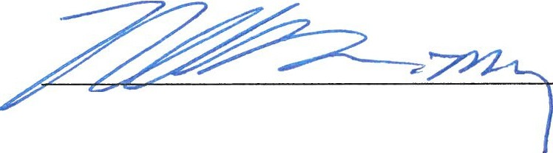

Rusty Moore, Mayor

Rusty Terry, City K tsercler

Passed on first reading April 15, 2024
77

Approved by Municipal Planning Commission December 19, 2023

Passed on second reading May 15, 2024

